Righting Software, First Edition

Copyright © 2020 Pearson Education, Inc.
ISBN-13: 978-0-13-652403-8
ISBN-10: 0-13-652403-6
Warning and Disclaimer
Every effort has been made to make this book as complete and as accurate as possible, but no warranty or fitness is implied. The information provided is on an “as is” basis. The author and the publisher shall have neither liability nor responsibility to any person or entity with respect to any loss or damages arising from the information contained in this book.
When reviewing corrections, always check the print number of your book. Corrections are made to printed books with each subsequent printing.
First Printing: December 2019
Text changes, all formats. Page numbers and location based on paper format.
Page | Error | Correction
ii, Kory Torgersen quote, paragraph 4, line 2 | applying engineering principals | applying engineering principles
xxviii, Chapter 9 section, paragraph 4, line 2 | by working cleaning and correctly | by working cleanly and correctly
47, “Resist the Siren Song” subsection, paragraph 2, line 2 | the Straights of the Sirens | the Straits of the Sirens
57 paragraph 2, line 5 | The presence of a nested “if” tells you that you  should to draw the use case | The presence of a nested “if” tells you that you  should draw the use case
85, paragraph 4, line 1 | Most of the use cases are variations of other  user cases | Most of the use cases are variations of other  use cases
113, paragraph 2, last line. | (see Figure 5-12) | (see Figure 5-13)
122, paragraph 2, line 2 | in the Mangers | in the Managers
162, paragraph 3, line 1 | with high uncertainly | with high uncertainty
168, Figure 7-5, labels | 14 EngineA  15 EngineB  16 EngineC  17 ManagerA  18 ManagerB | 14 Engine A  15 Engine B  16 Engine C  17 Manager A  18 Manager B
182, Figure 7-15, legend | Test Engineers | Test Engineer
198, Figure 8-3, source line in caption | Critical Path in Construction Practice | Critical Path Methods in Construction Practice
199, boxed text, footnote e | Critical Path in Construction Practice | Critical Path Methods in Construction Practice
201, Figure 8-5 | 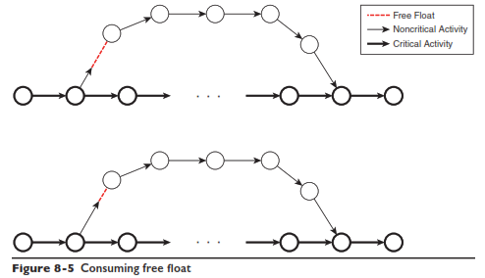 | 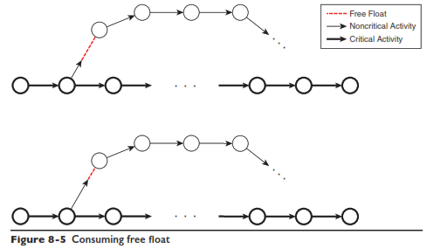
202, footnote 1 | Critical Path in Construction Practice | Critical Path Methods in Construction Practice
215, Figure 9-3, source line in caption | Critical Path in Construction Practice | Critical Path Methods in Construction Practice
217, Figure 9-4, source line in caption | Critical Path in Construction Practice | Critical Path Methods in Construction Practice
224, Figure 9-9, source line in caption | Critical Path in Construction Practice | Critical Path Methods in Construction Practice
225, boxed text, footnote c | Critical Path in Construction Practice | Critical Path Methods in Construction Practice
248, paragraph 3, sentence 3 | wor0k | work
268, paragraph 2, line 2 | on an staﬃng plan | on a staﬃng plan
281,  Table 11-5 | 14 EngineA  15 EngineB  16 EngineC  17 ManagerA  18 ManagerB | 14 Engine A  15 Engine B  16 Engine C  17 Manager A  18 Manager B
285,  Table 11-7 | 17 ManagerA  18 ManagerB | 17 Manager A  18 Manager B
285,  Table 11-7 | 26 ManagerA Simulator  27 ManagerB Simulator | 26 Manager A Simulator  27 Manager B Simulator
286, Figure 11-18, x-axis | 11/28 | 1/28
323, Figure 12-7, legend | Acual | Actual
396, Figure A-4 | The “tails” of the axes extend beyond zero:
420, paragraph 1, line 2 | complexly of the code | complexity of the code
429, Project Tracking Guidelines, #4 | Never base your progress reports on features | Never base progress reports on features

