Righting Software 1st Edition

Copyright © 2020 Pearson Education, Inc.
ISBN-10: 0136524036
ISBN-13: 978-0136524038
Warning and Disclaimer
Every effort has been made to make this book as complete and as accurate as possible, but no warranty or fitness is implied. The information provided is on an "as is" basis. The author and the publisher shall have neither liability nor responsibility to any person or entity with respect to any loss or damages arising from the information contained in this book or from the use of the CD or programs accompanying it.
When reviewing corrections, always check the print number of your book. Corrections are made to printed books with each subsequent printing.
First Printing: December 2019

Corrections for April 08, 2020
Text changes, all formats. Page numbers and location based on paper format.
Page | Error – 1st Printing | Correction
198 | Critical Path in Construction Practice | Critical Path Methods in Construction Practice
199 | Critical Path in Construction Practice | Critical Path Methods in Construction Practice
202 | Critical Path in Construction Practice | Critical Path Methods in Construction Practice
215 | Critical Path in Construction Practice | Critical Path Methods in Construction Practice
217 | Critical Path in Construction Practice | Critical Path Methods in Construction Practice
224 | Critical Path in Construction Practice | Critical Path Methods in Construction Practice
225 | Critical Path in Construction Practice | Critical Path Methods in Construction Practice
286,  Figure 11-18 | 11/28 | 1/28

Corrections for March 04, 2020
Text changes, all formats. Page numbers and location based on paper format.
Page | Error – 1st Printing | Correction
Front matter, page II, in Kory Torgersen praise, paragraph 4, line 2 | applying engineering principals | applying engineering principles
xxviii PREFACE, in the chapter 9 section, paragraph 4, line 2 | by working cleaning and correctly | by working cleanly and correctly
57 paragraph 2, line 5 | The presence of a nested “if” tells you that you  should to draw the use case | The presence of a nested “if” tells you that you  should draw the use case
85, paragraph 4, line 1 | Most of the use cases are variations of other  user cases | Most of the use cases are variations of other  use cases
113, paragraph 2, last line. | (see Figure 5-12) | (see Figure 5-13)
122, paragraph 2, line 2 | in the Mangers | in the Managers
162, paragraph 3, line 1 | with high uncertainly | with high uncertainty
248, 3rd paragraph, 3rd sentence. | wor0k | work
268, paragraph 2, line 2 | on an staﬃng plan | on a staﬃng plan
281,  Table 11-5 | 14 EngineA  15 EngineB  16 EngineC  17 ManagerA  18 ManagerB | 14 Engine A  15 Engine B  16 Engine C  17 Manager A  18 Manager B
285,  Table 11-7 | 17 ManagerA  18 ManagerB | 17 Manager A  18 Manager B
285,  Table 11-7 | 26 ManagerA Simulator  27 ManagerB Simulator | 26 Manager A Simulator  27 Manager B Simulator
420, paragraph 1, line 2 | complexly of the code | complexity of the code
429, Project Design Guidelines, #4 | Never base your progress reports on features | Never base progress reports on features
Figure Changes, all formats. Please have Michael Tanamachi (the designer) rework these.

Page | Error – 1st Printing | Correction
168,  Figure 7-5 | 14 EngineA  15 EngineB  16 EngineC  17 ManagerA  18 ManagerB | 14 Engine A  15 Engine B  16 Engine C  17 Manager A  18 Manager B
182, Figure 7-15 in the legend | Test Engineers | Test Engineer
201,  Figure 8-5 | 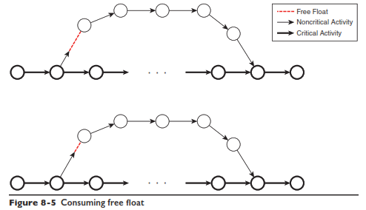 | 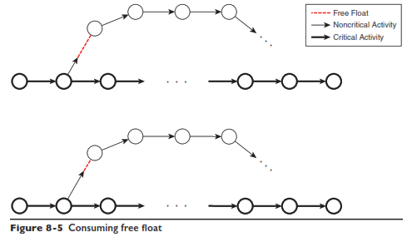
323,  Figure 12-7 in the legend | Acual  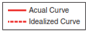 | Actual  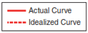
396,  Figure A-4 | Trim the tails of the axis

Paper printed format only, for the Pearson reprint team:

In the following figures, the dark blue in the original figure is printed as purple (and not a consistent shade of purple at that).

Page | Figure | Comment
219 | 9-5 | Compare with 9-8 on page 221
219 | 9-6 | Compare with 9-8 on page 221
191 | 7-22 | Across the page from 7-21 that is in the correct blue
191 | 7-23 | Across the page from 7-21 that is in the correct blue
202 | 8-6 | The text refers to it as blue, it is very purple
215 | 9-3 | Not as bad as the rest, but still purple instead of blue
226 | 9-10 | Compare with 9-9 on page 224
227 | 9-11 | Compare with 9-12 on page 228
266 | 11-7 | Not as bad as the rest, but compare with 11-12 on page 271
274 | 11-15 | Compare with 11-12 on page 271
278 | 11-16 | Should be light and dark blue, instead there is light blue and purple

