CompTIA A+ 220-901 and 220-902 Cert Guide
First Edition

Copyright © 2017 Pearson Education, Inc.
ISBN-10: 0-7897-5652-8
ISBN-13: 978-0789705652-7
Warning and Disclaimer
Every effort has been made to make this book as complete and as accurate as possible, but no warranty or fitness is implied. The information provided is on an "as is" basis. The author and the publisher shall have neither liability nor responsibility to any person or entity with respect to any loss or damages arising from the information contained in this book or from the use of the CD or programs accompanying it.
When reviewing corrections, always check the print number of your book. Corrections are made to printed books with each subsequent printing.
First Printing: August 2016

Corrections for May 29, 2017
Pg | Error – First Printing | Correction
29 | Chapter 1, Answer to Question 10  Reads:  10. A. Laser toner particles are too small to be captured by a standard vacuum cleaner bag. You should use a vacuum and bag that is especially designed for toner. | Should read:  10. A. Laser toner particles are too small to be captured by a standard vacuum cleaner bag. You should use a vacuum cleaner bag that is especially designed for toner.
62 | Chapter 2, Question 11  Reads:  11. What is the power management system used for in modern computers? | Should read:  11. What is the power management system used in modern computers?

63 | Chapter 2, Question 14, Remove Definitions 6 and 7
93 | Chapter 3, Question 3, Answers  Reads:  - Mini-ITX  - ATX  - Mini-ITX | Should read:  - Mini-UTX  - ATX  - microATX
97 | Chapter 3, Answers to Question 3  Reads:  3. 1. A; 2. C; 3. B | Should read:  3. 1. B; 2. C; 3. A
123 | Chapter 4, Answer to Question 9  9. B. For best results, you should always install identical modules in the same  channel. The two 4GB modules should be the same size, speed, latency, and so on, and should be installed in the same channel (in this case, in the two blue slots). The same is true for the two 2GB modules, which should be installed in the two black slots. The slots on this motherboard are color-coded to indicate the channels. Always check your documentation for the correct orientation of the channels and the type of RAM your motherboard will accept. | Should read:  9. A. For best results, you should always install identical modules in the same  channel. The two 4GB modules should be the same size, speed, latency, and so on, and should be installed in the same channel (in this case, in the two blue slots). The same is true for the two 2GB modules, which should be installed in the two blue slots. The slots on this motherboard are color-coded to indicate the channels. Always check your documentation for the correct orientation of the channels and the type of RAM your motherboard will accept.
188 | Chapter 6, Safely Ejecting a USB Drive in Linux, Second Command  Reads:  sudo unmount /dev/sbd1 (where sbd1 is the mounted USB drive)—When the drive access light goes out, disconnect the drive. | Should read:  sudo unmount /dev/sdb1 (where sbd1 is the mounted USB drive)—When the drive access light goes out, disconnect the drive.
198 | Chapter 6, Question 2  Reads:  2. Your client is considering purchasing a tablet with eMMC storage. Which one of the following is a correct statements? | Should read:  2. Your client is considering purchasing a tablet with eMMC storage. Which one of the following is a correct statement?
198 | Chapter 6, Question 2, Answer a  Reads:  - The tablet will have faster data access than if it used an SSD. | Should read:  - The tablet will have faster data access than if it is used in SSD.
198 | Chapter 6, Question 2, Answer d  Reads:  d. The tablet will have slower data access than if it used an SSD. | Should read:  d. The tablet will have slower data access than if it is used an SSD.
199 | Chapter 6, Question 6  Reads:  6. The user has a reported a failure with an eSATA drive. Assuming the drive is configured as AHCI in the system BIOS, which of the following is the correct procedure to replace it? | Should read:  6. The user has reported a failure with an eSATA drive. Assuming the drive is configured as AHCI in the system BIOS, which of the following is the correct procedure to replace it?
256 | Chapter 8, Note  Reads:  NOTE A fourth standard, USB 3.1, was introduced in 2015. To learn more about USB 3.1, see “USB 3.1,” this chapter, p.206. | Should read:  NOTE A fourth standard, USB 3.1, was introduced in 2015. To learn more about USB 3.1, see “USB 3.1,” this chapter, p.260.
265 | Chapter 8, Note  Reads:  NOTE A hybrid keyboard or mouse is one designed to work with either USB or PS/2 ports. Adapters bundled with a mouse or keyboard, such as the ones shown in  Figure 8-10, can be used only on mice or keyboards that are designed to work with either type of port. A USB to PS/2 adapter sold at retail stores can also work with  PS/2-only devices. | Should read:  NOTE A hybrid keyboard or mouse is one designed to work with either USB or PS/2 ports. Adapters bundled with a mouse or keyboard, such as the ones shown in  Figure 8-11, can be used only on mice or keyboards that are designed to work with either type of port. A USB to PS/2 adapter sold at retail stores can also work with  PS/2-only devices.
285 | Chapter 8, Last Paragraph  Reads:  Analog audio can connect to receivers and is used in gaming. However, for digital output (such as from a DVD or Blu-ray), you need digital audio. HDMI carries both digital video and audio, but for situations in which HDMI cannot be used (for example, with a receiver lacking HDMI inputs), you can use SPDIF digital output (refer to Figure 8-1, p.201, for typical examples). | Should read:  Analog audio can connect to receivers and is used in gaming. However, for digital output (such as from a DVD or Blu-ray), you need digital audio. HDMI carries both digital video and audio, but for situations in which HDMI cannot be used (for example, with a receiver lacking HDMI inputs), you can use SPDIF digital output (refer to Figure 8-1, p.254, for typical examples).
297 | Chapter 8, Answers and Explanations to Review Questions, Answers to Question 3  Reads:  3. 1—USB Type B; 2—USB Mini-B; 3—USB Type A. | Should read:  3. C; 2. D; 3. B; 4. E; 5. F; 6. A
298 | Chapter 8, Answers to Question 7  Reads:  7. D. Port 4 is a DVI-D port that carries only digital video. Port 1 connectors are DVI-I and carry both digital and analog signals. Port 2 is an HDMI port that carries a high-definition digital video signal and a digital audio signal in a single cable. Port 3 is a VGA port and carries an analog video signal. | Should read:  7. E. Mini-HDMI (1) and HDMI (3) carry digital A/V signals but can be adapted to VGA (analog) video). DVI-I (2) carries digital video signals but can be adapted to VGA (analog) video. VGA (4) carries analog video only. DVI-D (5) carries only digital video only.
298 | Chapter 8, Answers to Question 11  Reads:  11. 1—DisplayPort to HDMI; 2—Mini DisplayPort VGA; 3—Mini DisplayPort to DVI-I; 4—DisplayPort to DVI-D; 5—Mini DisplayPort HDMI. | Should read:  11. 1. B; 2. C; 3. A; 4. E; 5. D
298 | Chapter 8, Answers to Question 12  Reads:  12. 1—Microphone; 2—Headphones; 3—SPDIF optical. | Should read:  12. 1. C; 2. F; 3. E
953 | Chapter 18, Answer to Question 10, Last Sentence  Reads:  End and FQ are not valid terminal commands. | Should read:  end and fq are not valid terminal commands.
1104 | Chapter 22, Second Heading  Reads:  Missing Operating System | Should read:  Missing Operating System / Missing NTLDR
1151 | Glossary  Reads:  802.11a A wireless Ethernet standard that uses 5GHz radio signals and provides performance at rates from 6Mbps up to 54Mbps. It is not compatible with other 802.11-based wireless networks unless dual-band access points are used. | Should read:  802.11a A wireless Ethernet standard that uses 5GHz radio signals and provides performance at rates from 6Mbps to 54Mbps. It is not compatible with other 802.11-based wireless networks unless dual-band access points are used.
1154 | Glossary, A  Reads:  Analog (audio) Continuous vibrations at different pitched and frequencies—not sampled. | Should read:  Analog (audio) Continuous vibrations at different pitches and frequencies—not sampled.
1158 | Glossary, C  Reads:  CardBus 32-bit version of PC Card add-on card used in laptops. | Should read:  CardBus 32-bit version of PC Card add-on card used in very old laptops.
1163 | Glossary, D  Reads:  DDR2 SDRAM Double-Double Data-Rate SDRAM (DDR2 SDRAM) is the successor to DDR SDRAM. | Should read:  DDR2 SDRAM Double Data-Rate SDRAM (DDR2 SDRAM) is the successor to DDR SDRAM.
1165 | Glossary, D  Reads:  DISKPART Window command-line utility for creating and managing disks, partitions, and volumes. | Should read:  DISKPART Windows command-line utility for creating and managing disks, partitions, and volumes.
1184 | Glossary, L  Reads:  loud noise A loud “bang” or “pop” noise, often accompanied by smoke or a chemical odor, usually indicates the failure of a capacitor on the motherboard on in the power supply. The component must be replaced, and if the power supply is affected, it could have damaged other components as well. | Should read:  loud noise A loud “bang” or “pop” noise, often accompanied by smoke or a chemical odor, usually indicates the failure of a capacitor on the motherboard or in the power supply. The component must be replaced, and if the power supply is affected, it could have damaged other components as well.
1188 | Glossary, N-O  Reads:  network card Network adapter: connects a computer to a network. Term is also used for integrated network adapters and for USB network adapters. | Should read:  network card Connects a computer to a network. Term is also used for integrated network adapters and for USB network adapters.

1191 | Glossary, P-Q  Reads:  PCIe 6/8-pin Power leads from the power supply used to power PCIe video cards. Some cards use the six-pin connection; some the eight-pin connector. | Should read:  PCIe 6/8-pin Power leads from the power supply used to power PCIe video cards. Some cards use the six-pin connection; some use the eight-pin connector.
1208 | Glossary, S  Reads:  streaks Streaks on a page output by a laser printer indicate it needs replacement toner and possibly other maintenance. With other printers, suggests dirty rollers in the paper path. | Should read:  streaks On a laser printer, can be caused by a damaged imaging drum or toner cartridge or by dirty rollers. With other printers, suggests dirty rollers in the paper path.
1214 | Glossary, U-V  Reads:  vacuum (cleaner) | Should read:  vacuum cleaner

Corrections for January 16, 2017
Pg | Error – First Printing | Correction
39 | Chapter 2, Replace Figure 2-4 | Replacement Figure  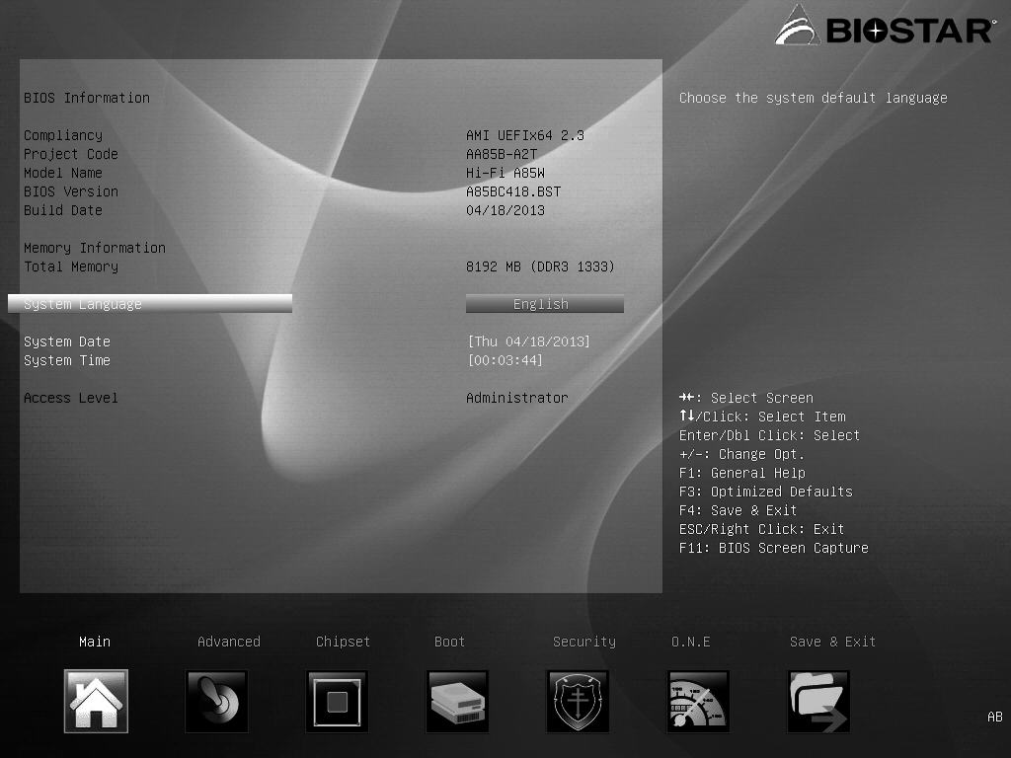
41 | Chapter 2, Replace Figure 2-7 | Replacement Figure  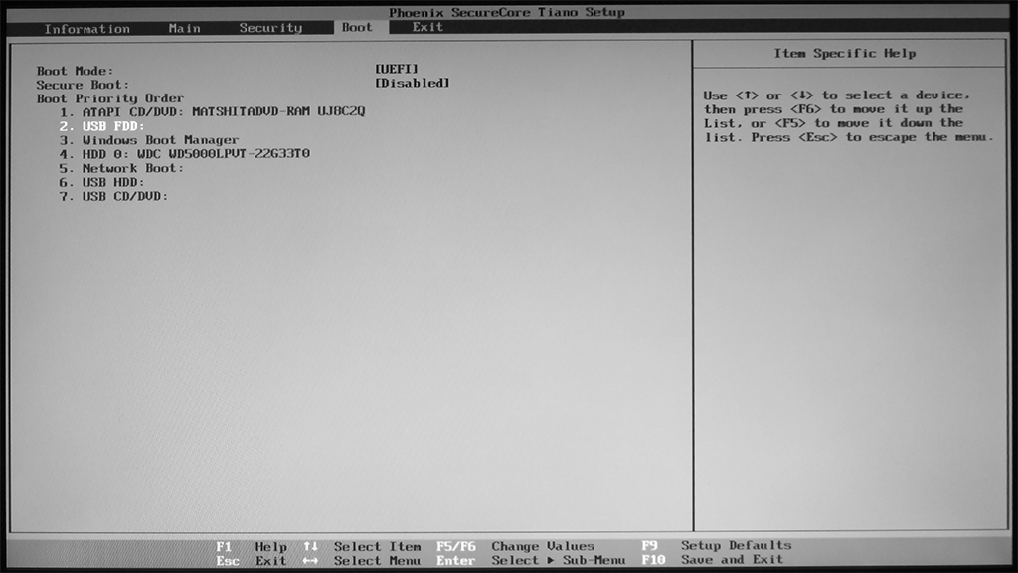

45 | Chapter 2, Replace Figure 2-11 | Replacement Figure  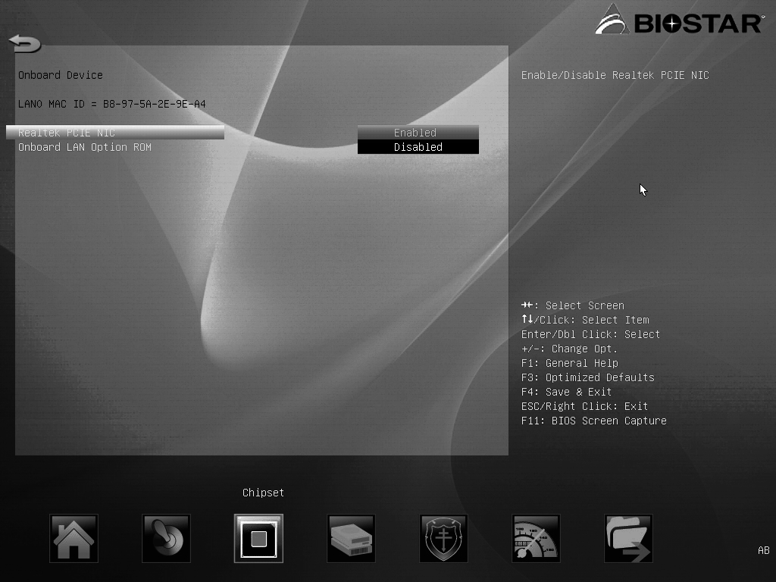
97 | Chapter 3, Answers and Explanations to Review Questions, Number 3  Reads:  3. 1. A; 2. C; 3. B. |  | Should read:  3. 1. B; 2. C; 3. A.
207 | Chapter 7, Replace Figure 7-1 | Replacement Figure  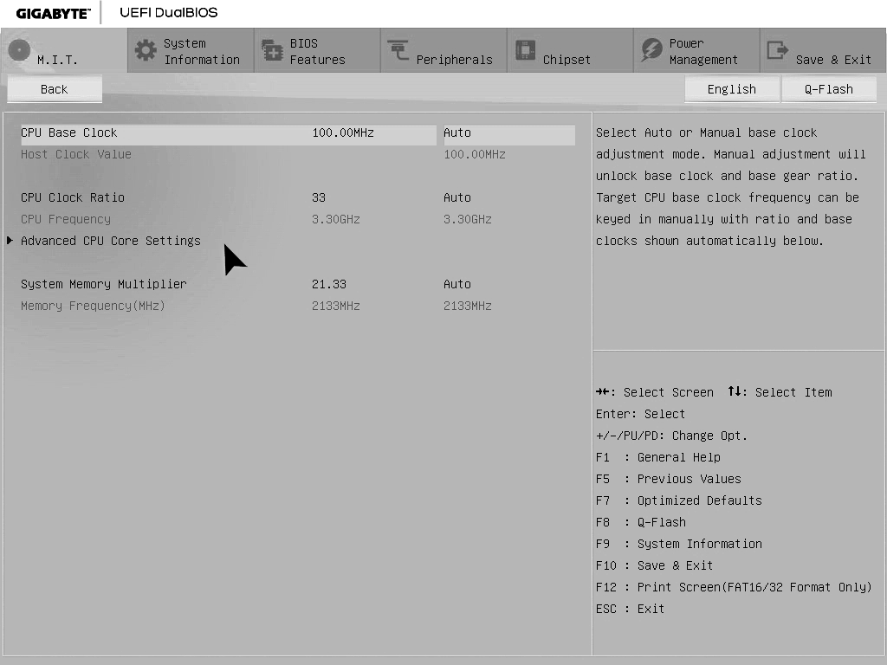

207 | Chapter 7, Replace Figure 7-2 | Replacement Figure  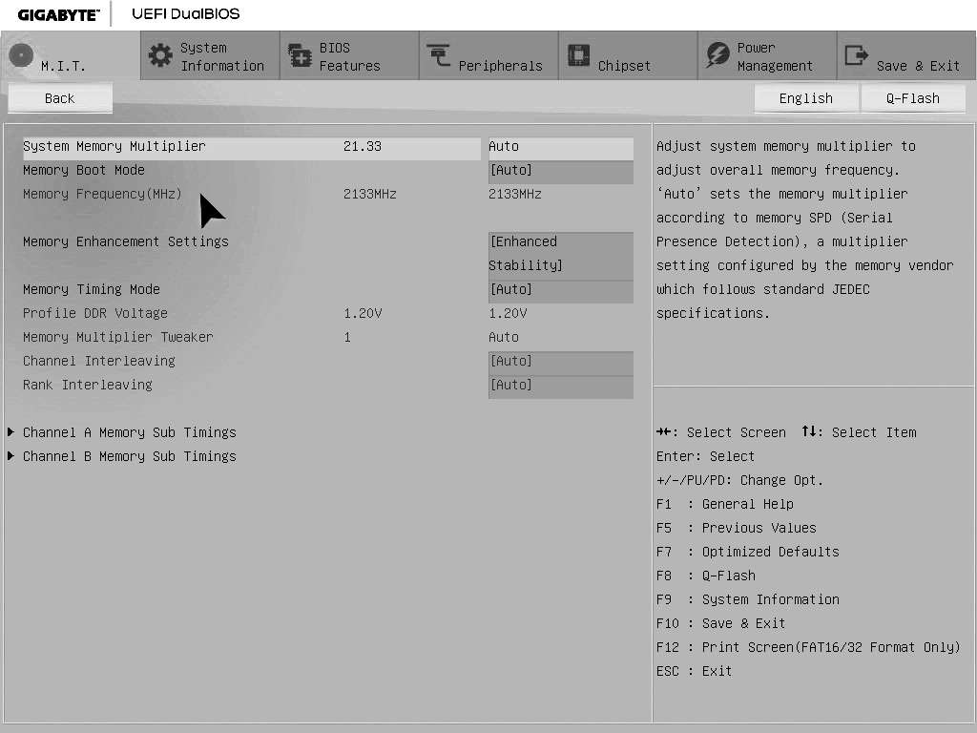

This errata sheet is intended to provide updated technical information. Spelling and grammar misprints are updated during the reprint process, but are not listed on this errata sheet.

