Product Analytics: Applied Data Science Techniques for Actionable Consumer Insights

First Edition

Copyright © 2021 Pearson Education, Inc.
ISBN-13: 978-0-13-525852-1
ISBN-10: 0-13-525852-9

Warning and Disclaimer
Every effort has been made to make this book as complete and as accurate as possible, but no warranty or fitness is implied. The information provided is on an "as is" basis. The author and the publisher shall have neither liability nor responsibility to any person or entity with respect to any loss or damages arising from the information contained in this book or from the use of the CD or programs accompanying it.
When reviewing corrections, always check the print number of your book. Corrections are made to printed books with each subsequent printing.
First Printing: October 2020

Corrections for July 5, 2022
Page No. | Error – First printing | Correction
73 | Add after last second paragraph, second line which reads: “That’s 6 feet 6.8 inches, or about 6 feet 7 inches.”  The sample mean is given by the following equation:  Sample mean = 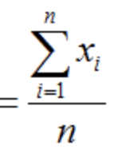  Don’t be frightened by the summation symbol, ∑, it’s just a fancy way to say be add up alll the observations, like we did with the mean.
79 | Add before 4.1.8 The Exponential Distribution,  “If it’s a curve, it can get complex quickly. You could use the local minimas/maximas or points of change in curvature or concavity (called inflection points) as metrics. Sometimes you can eyeball these and get accurate approximations. If not, a quick and dirt way to get some approximations is if you can estimate the density function with a polynomial or another type of function. With R, you can try and fit a range of polynomials or other types of functions until it closely resembles your density plot. If you get a functional approximation, you can calculate the first and second derivative functions of that functional approximation. With the first derivative function, you can find the slope at any point. With the second derivative function, you can find the inflection points of the density distribution.”
80 | Equation at the top of the page reads:  y = e- x | Should read:  y=$e^{-λ*x}{}^{}$  *lambda is the mathematical symbol lambda
80 | First paragraph, second sentence reads:  For instance, 2x grows like this:  2^1 = 2, 2^2 = 4, 2^3 = 16, 2^4 = 32, 2^5 = 64, 2^6 = 128, …. | Should read:  For instance, $2^{x}$ grows like this:  $2^{1}$= 1, $2^{2}$=4, $2^{3}$=8, $2^{4}$=16, $2^{5}$=32
128 | First equation reads:  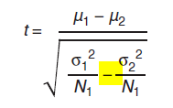 | In the denominator under the square root, it should be a plus not a minus.  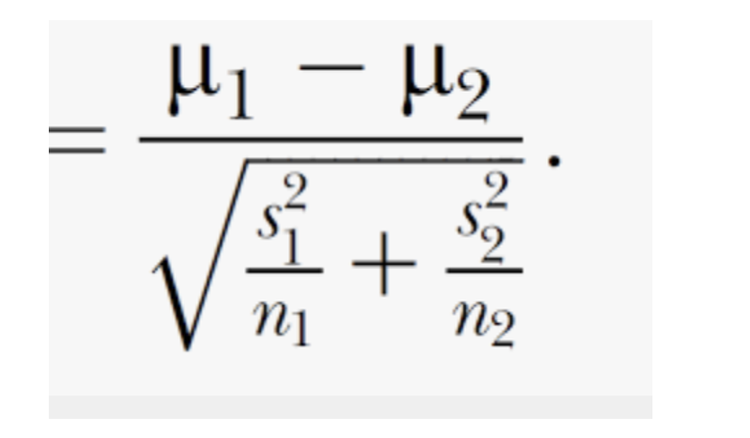
129 | Figure 6.10, caption reads:  Figure 6.10 Kaplan–Meier curve of Survival curve for user time on a web page. | Should read:  Figure 6.10 Survival curve for user time on a web page.
129 | Title of figure reads:  KM Curve of Time on Page | Should read:  Survival Curve of Time on Page
131 | Equation reads:  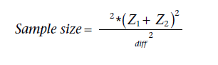  where s^2 is the variance, mdiff is the size of the effect, Z1 is the Z – score of the level of statistical significance for the test and Z1 is the Z – score for the power of the hypothesis test | Should read:  Sample size =$\frac{{{{σ^{2}}^{}* ({Z_{test} +Z_{power})^{2}}_{}}^{}}^{}{}^{}}{diff^{2}}$  , where 𝜎 is standard deviation, diff is size of the effect, $Z_{test}$ is Z value for the level of statistical significance for the test, $Z_{power}$is Z value for the desired power of the hypothesis test. Please note, with this formula we’re assuming that the ratio of treatment to control is 1.
145-146 | Linear Algebra and Mathematics Behind PCA should read:  The mathematical derivation of PCA results is complex. As a practitioner, you’ll never need to derive the PCA by hand. This section is to help those interested in the underlying mathematical process explore a numeric example.  Linear algebra is a framework that uses matrices to represent linear equations. It’s useful because we can define high dimensional spaces with simple equations. Linear algebra also allows us to invert these equations and calculate important values based on a set of equations, rather than just one or two.  Principal components analysis is based on eigenvectors, a core concept in linear algebra. In this sidebar, we will go through a simple example of calculating eigenvectors. We’ll see eigenvectors/values come up again in Chapter 9 in examples of population projection.  The following will be a two-dimensional example of calculating eigenvectors and values. From the eigenvectors, we’ll calculate the component size and rotation.  We’ll start with a simple example. We are measuring the height and width of various flowers in our backyard. We are able to measure the height and width of 6 flowers. These measurements are represented in the following matrix:  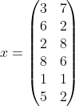  The first step is to calculate the covariance matrix. Covariance is a measure of correlation between two variables. When there are multiple variables, the dependency between the variables is represented by a covariance matrix. For a vector of size n, the covariance matrix is of size n x n, the element [i, j] of the covariance matrix represents the covariance between the ith and jth element of the vector.  We went through an example of calculating the covariance coefficient in Chapter 7. We will not repeat this calculation here (but you can try to calculate this yourself and see if you get this result). If you do not want to calculate this by hand, use R to calculate the covariance matrix for our two-dimensional example. You can use the ‘cov()’ function on the matrix above to get this result. The size of the covariance matrix in this case 2 x 2 as shown here:  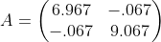  Then, the next step is to calculate the eigenvectors and eigenvalue. The idea behind an eigenvector is to find a scalar or number that corresponds to a matrix. It’s a little complex to find this as you can imagine. It’s based on this equation:  $$Av=λv,$$  where A is a matrix with certain properties, v is a matrix with eigenvectors and lambda is the eigenvalue or numerical value or scalar.  Then the characteristic polynomial:  $$\left|A-λI\right|=0whereIistheidentitymatrix$$  We calculate the eigenvectors for our characteristic polynomial for this two-dimensional covariance matrix:  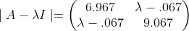  =$($6.967−𝜆$)($9.067− 𝜆)−−${.067}^{2}$  $=63.1653-16.034λ+λ^{2}$  Then, we can solve for the roots of this quadratic equation. We can also get the eigenvalues from our covariance matrix above by using the eigen() function in R. Using eigen_result$values will give us the eigenvalues for our characteristic polynomial. We get eigenvalues of 9.07 and 6.97. We can then take the square root and sum them, which 5.65. We divide the square root of each by 5.65 to get components equal to 53% and 47% respectively. This is the size of the first component (53%) and second component (47%).  Now that we have component sizes, we can calculate the rotations. To do that we need to solve for the eigenvectors:  We need to solve the following equations for the x’s =  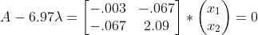  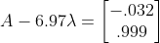  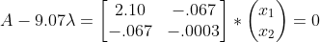  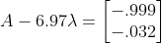  The two eigenvectors give us the composition of the components. The first eigenvector is the first component and the second eigenvector is the second component, which are primarily in the direction of each feature. This is because the components are pretty uncorrelated (we can see that from the correlation matrix). Hopefully, this gives a little insight into PCA.

