Transport Processes and Separation Process Principles
5th Edition

Copyright © 2018 Pearson Education, Inc.

ISBN-10: 0-13-418102-6
ISBN-13: 978-0-13-418102-8

Warning and Disclaimer
Every effort has been made to make this book as complete and as accurate as possible, but no warranty or fitness is implied. The information provided is on an "as is" basis. The author and the publisher shall have neither liability nor responsibility to any person or entity with respect to any loss or damages arising from the information contained in this book or from the use of the CD or programs accompanying it.
When reviewing corrections, always check the print number of your book. Corrections are made to printed books with each subsequent printing.

Corrections to the first printing (April 2018)

Pg | Error | Correction
7 | In section 1.2B:  1 g mass (g) = 1×10²³ kg mass (kg) 1 cm = 1×10²² m  1 dyne (dyn) = 1 g ⋅ cm/s² = 1×10²⁵ newton (N) 1 erg = 1 dyn ⋅ cm = 1×10²⁷ joule (J) | = 1 ×10⁻³ kg  = 1 ×10⁻² m  = 1 ×10−5 newton  = 1 ×10⁻⁷ joule  (Erroneous “2”s in exponents should be minus signs.)
74 | Figure 4.2-3 doesn’t refer to Example 4.2-2 | Corrected section 4.2E is available for download from informit.com/title/9780134181028

87 | Eq. (4.3-29):  Ry = mv2 sin α₂ − mv1 sin α₁ + p2 A2 sin α₂ − p1 A1 sin α_{J} + mt g | Ry = mv2 sinα₂ − mv1 sinα₁ + p2 A2 sinα₂ − p1A1 sinα₁ + mtg  (Subscript “j” should be “1”)
91 | Eq. (4.4-3):  (rτ rx ) r+Δr −(rτ rx ) r ( p x − p x+Δr )  Δ r = Δ  r x | (rτ rx )r+Δr − (rτ rx ) r = r ( p x − p x+Δx )  Δr Δx
101 | Second-to-last line of Problem 4.2-12: “Calculate the lost work 0.1133 m3/s. friction loss)” | “Calculate the lost work 0.1133 m3/s (friction loss)”
139 | Third-to-last line of Problem 5.1-1:  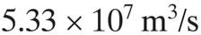 | 5.33×10−7 m3 /s (Add minus sign in exponent.)
217 | Last full line of Problem 8.3-3:  vz − vz max . | vz = vz max.  (Change minus sign to equals sign.)
290 | In first line of Example 12.6-3: “Recalculate Example 12.6-1 for combined radiation” | “Recalculate Example 12.5-1 for combined radiation”
379 | Last sentence of problem 14.2-3: “Show that Eq. (6.2- 3) holds by starting with Eq. (6.2-1).” | “Show that Eq. (14.2-3) holds by starting with Eq. (14.2-1).”
381 | First sentence of Problem 14.4-2: “Use the same conditions as in Problem 6.4-1 but” | “Use the same conditions as in Problem 14.4-1 but”
381 | First sentence of Problem 14.4-3: “Use the same conditions as in Problem 6.4-1” | “Use the same conditions as in Problem 14.4-1”
381 | Last sentence of Problem 14.4-5: “Also, Eq. (6.4-7) should be used.” | “Also, Eq. (14.4-7) should be used.”
381 | First sentence of Problem 14.4-6: “Repeat Problem 6.4-5” | “Repeat Problem 14.4-5”
381 | First sentence of Problem 14.4-7: “For the conditions of Example 6.4-3” | “For the conditions of Example 14.4-3”

381 | First sentence of Problem 14.4-8: “Repeat Example 6.4-3, but instead use the alternative boundary condition, Eq. (6.4-11).” | “Repeat Example 14.4-3, but instead use the alternative boundary condition, Eq. 14.4-11).”
383 | In Problem 14.6-5:  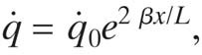 | −β x /L  q = q₀e ,  (Erroneous "2" in exponent should be a minus sign.)
435 | Eq. (15.8-18):  A_{f} = 2π ( L_{c} xw) (longitudinal fin) | [Delete second part of equation—it is not needed.]
451 | Eq. (16.3-12):  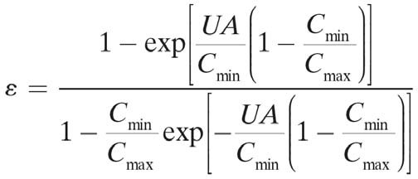 | Use the same conditions as in Problem 14.4-1 but with the following change.  1− exp ⎡ −UA ⎛1− Cmin ⎞⎤  ⎢ C ⎜ C ⎟⎥  ε = ⎣ min ⎝ max ⎠⎦  1− Cmin exp ⎡ −UA ⎛1− Cmin ⎞⎤  C ⎢ C ⎜ C ⎟⎥  max ⎣ min ⎝ max ⎠⎦
681-  682 | 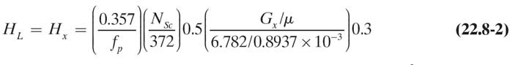 | ⎛ 0.226 ⎞⎛ N ⎞0.5 ⎛ G ⎞−0.5 ⎛ G ⎞0.35  y  HG = Hy = ⎜ ⎟⎜ Sc ⎟ ⎜ x ⎟ ⎜ ⎟ (22.8-1)  ⎝ f p ⎠⎝ 0.660 ⎠ ⎝ 6.782 ⎠ ⎝ 0.678 ⎠  ⎛ 0.357 ⎞⎛ N ⎞0.5 ⎛ G μ ⎞0.3  HL = Hx = ⎜ ⎟⎜ Sc ⎟ ⎜ x ⎟ (22.8-2)  −3  ⎝ f p ⎠ ⎝ 372 ⎠ ⎝ 6.782 0.8937 ×10 ⎠
1152 | Continuation of Table A.5-1 contains errors in the right-most column | Complete, corrected Table A.5-1 is available for download from informit.com/title/9780134181028
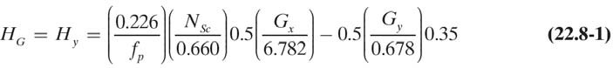
This errata sheet is intended to provide updated technical information. Spelling and grammar misprints are updated during the reprint process, but are not listed on this errata sheet.

